# Chatbot Project Analysis report using NLP

***For***



***By,***

Aravindh JAWAHAR  
Saravana Kumar JAISHANKAR

Siddharth RAMESH

MSS September 2021

***Guided***

***by,***

MOUTYMBO Charles-Alexis

***For course,***

Application Project

Semester III

MSS September 2021

**Index**

**Contents**

1. Abstract …………………………………………………………………………………………………………………….3
2. Chatbot varieties and ideas ……………………………………………………………………………………….3
3. Opted chatbot type for implementation of project ……………………………………………………5

**Appendix**

References ………………………………………………………………………………………………………………6

**Table of figures**

1. Chatbot …………………………………………………………………………………………………………………….3
2. Implementation diagram ………………………………………………………………………………………….5

**A . Abstract**

ESAIP engineer school has the website which requires the chatbot application for the institution to answer the query of the new students approaching for the admission or to know about the courses available and its campus life among with the details requiring the admission process to join and to proceed on. The application will have the machine learning algorithm undergoing the training on Natural language processing (NLP) and using the inference the system will answer the question/query given by any individual on the website with the chatbot. The chatbot will infer with the knowledge base and some Frequently asked questions(FAQ’s) inputted over the database along with its response. The knowledge base will be trained to give response with NLP and stores the questions if it is new to the base. The ‘To be contacted’ portal will be enabled on the chatbot if in case the individual enquiring the chatbot about the academics needed discussion with the panel of admission members.

**B . Chatbot varieties and ideas**

There are numerous varieties of chatbot types available for specific purposes, this section of the document explains about the types and its usages over the websites for specific business.

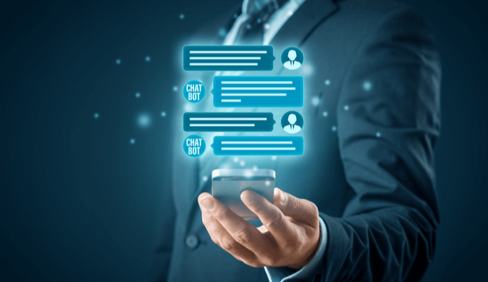

**1 . Chatbot**

Chatbot has more **benefits** as compared to the traditional service with the support having the person behind. The model has been trained with the Natural Language Processing (NLP) along with the knowledge base with FAQ’s. This model will learn itself using the machine learning algorithm on usage and add it to knowledge base by learning . These learned inferences will be used as insights on usage or chat with any individuals.

**Types of Chatbot[1]:**

* Support chatbots
* Skill chatbots
* Assistant chatbots

**Support Chatbots:**

It is built with mastering of single domain, for instance about the organization or company. It should have context awareness. It should be able to walk a user through any business process and answer a wide range of FAQ’s. It should ensure that it can execute the actions like selling cards to the persons.

**Skill chatbots:**

This type of chatbots are typically more single-turn-type bots that do not require a lot of contextual awareness. They set commands that are intended to do business perfect. Users can multi-task while engaging a bot. It doesn’t need to worry too much about contextual awareness unless you want to design a particularly advanced one. Its important to focus on integration especially when controlling with personalized objects.

**Assistant chatbots:**

It is the middle ground between the two bots above. They work best when they know a little about the variety of topics. Many people Many people envision these bots will someday become navigators of all other bots that are out there now. Assistant chatbots need to be conversational and respond to just about anything, while being as entertaining as possible. When building an assistant chatbot, it is important to make it as obvious as possible how the bot is trained. The range of questions a user might ask is large, so making sure you have adequate coverage is going to be the most difficult factor. In many cases, when people do not know what they should ask, they will not ask anything at all. And if you miss the few topics, they initially are willing to try, they will not come back for more.

No matter what type of bot you decide to build, it is important give bot some life and personality to make it useful. The possibilities are endless.

**C . Opted chatbot type for implementation of the Project:**

The chatbot chosen for implementation is **Skilled chatbot**. It will be specialised in one domain, in or instance we train our model about the school and its admission process corresponding its requirements to apply. The Notification will be added if in case the enquired person from the chatbot needed to be contacted by the person for admission process or regarding the business query if in case the individual needed to collaborate their organization for business integration with subject to conditions.

The implementation details for the development will be as follows:

**Front-end :** HTML CSS JavaScript

**Back-End :** Python and its libraries

**Knowledge Base :** MongoDB

**Machine learning :** Natural Language Processing

This model has been elected because the possibility of changing the bot’s in accordance with any constraints this model will be under ease of use for developers to change the motive if needed. The cost[2] of implementing is free of cost as the dedicated database for the chatbot has been used in order to support the application with knowledge base.

In the technical view the front-end module of the chatbot will be added to html script of the ESAIP school website as it is written in HTML CSS. The back-end integration will be added to the servers for supporting the chatbot on the website to answer the queries and for knowledge base learning.

The below diagram represents the architecture of the implementation using the 3-tier Model:

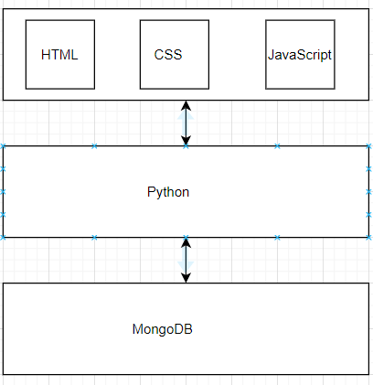

**2 . Implementation diagram**

**Appendix**

**References**

1. <https://www.ibm.com/blogs/watson/2017/12/3-types-of-business-chatbots-you-can-build/>
2. https://www.mongodb.com/pricing